**Topics: Normal distribution, Functions of Random Variables**

1. The time required for servicing transmissions is normally distributed with *μ* = 45 minutes and *σ* = 8 minutes. The service manager plans to have work begin on the transmission of a customer’s car 10 minutes after the car is dropped off and the customer is told that the car will be ready within 1 hour from drop-off. What is the probability that the service manager cannot meet his commitment?
2. 0.3875
3. **0.2676**
4. 0.5
5. 0.6987

**Answer:**

Time taken to service a car = 50 minutes.

P(X $≥$ 50) = 1 - P(X ≤ 50)

**Z-Score for X $≥$ 50:**

Here, X = 50, µ= 45, *σ* = 8 .

Z-Score for Probability of X≤ 50 = $\frac{X- µ}{}$ = $\frac{50-45}{8}$ = 0.625

Probability value for Z-score of 0.625 is 0.73565 that is 73.56%. (from Z-table)

P(X≤ 50) = 73.56%

**P(X>50)** = 100 – 73.565 = **26.44%**

**Probability** that the service manager will not meet his commitment is **26.44% or 0.2644.**

1. The current age (in years) of 400 clerical employees at an insurance claims processing center is normally distributed with mean *μ* = 38 and Standard deviation *σ* =6. For each statement below, please specify True/False. If false, briefly explain why.
2. More employees at the processing center are older than 44 than between 38 and 44.

**Answer:**

**μ = 38**

***σ* = 6**

Probability that the age of employee is greater than 44 = P(X>44)

P(X>44) = 1-P(X<44)

= 1 – P(Z at ((44-38)/6))

= 1 – P(Z at(1)

= 1 – 0.84134

P(X>44) = 0.15866

Probability that the age of employee is greater than 44 = 15.86%

Now, we have to find the probability of employee’s age being between 38 and 44.

P(38<X<44) = P(X<44) – P(X<38)

= 0.84134 – P(Z at ((38-38)/6))

= 0.84134 – P(Z at 0)

= 0.84134 – 0.50000

P(38<X<44) = 0.34134 = 34.13%

Since, [ **P(38<X<44) = 34.13% ] > [ P(X>44) = 0.15866 ]**

The probability that the employee age is between 38 and 44 is more than the probability of employee age being greater than 44.

Therefore, the given statement is **False**.

1. A training program for employees under the age of 30 at the center would be expected to attract about 36 employees.

**Answer:**

Probability that the employee age is less than 30 = P(X<30)

P(X<30) = P{Z = $\frac{X- µ}{}$ = (30-38)/6 } = -1.33

P(Z= -1.33) = 0.09176

**P(X<30) = 0.09176**

## So, the number of employees with probability (0.9176) of them being under age 30 = 400*0.09176

**= 36.704 $≅$ 36 Employees**.

Therefore, the given statement is **TRUE**.

1. If *X1* ~ *N*(μ, σ2) and *X*2 ~ *N*(μ, σ2) are iidnormal random variables, then what is the difference between 2 *X*1 and *X*1 + *X*2? Discuss both their distributions and parameters.

**Answer:**

According to the **Central Limit Theorem**, any large sum of independent, identically distributed (iid) random variables is approximately Normal.

The Normal distribution is defined by two parameters:

The mean, $μ$ and the variance, $σ^{2}$ and written as X~ N ($μ, σ^{2})$

Given: X1 ~N ( and X2 ~N ( are two independent identically distributed random variables.

From the properties of Normal Random Variables,

If X~ N ($μ_{1}, σ_{1}^{2}$) and Y~N ($μ_{2}, σ_{2}^{2}$) are two independent identically distributed random variables, then,

1. The sum of normal random variables is given by,

X + Y ~ N ($μ_{1}+ μ_{2}, σ_{1}^{2}+σ_{2}^{2})$,

1. And the difference of normal random variable is given by,

X – Y ~ N ($μ_{1}- μ_{2}, σ_{1}^{2}+σ_{2}^{2}$)

When Z = aX, the product of X is given by,

Z ~ N ($aμ_{1}, a^{2}σ_{1}^{2}$)

When Z = aX + bY, the linear combination of X and Y is given by

Z~ N ($aμ_{1}+ bμ_{2}, a^{2}σ_{1}^{2}+b^{2}σ_{2}^{2}$)

Given to find 2X1:

Thus, following the property of multiplication, we get

**2X1 ~ N (2,)**

**=> 2X1 ~ N (2 , 4)**

And following the property of addition,

**X1 + X2 ~ N (**

**=> X1 + X2 ~ N (2, 2)**

And the difference between the two is given by,

**2X1 – (X1 + X2) ~ N (2, 2 +4) ~ N (0, 6)**

The mean of 2 X1 and X1+ X2 is same but the variance ( of 2X1 is 2 times more than the variance of X1 + X2

The difference between the two says that the two given variables are **identically** and **independently distributed.**

1. Let X ~ N(100, 202). Find two values, *a* and *b*, symmetric about the mean, such that the probability of the random variable taking a value between them is 0.99.
2. 90.5, 105.9
3. 80.2, 119.8
4. 22, 78
5. **48.5, 151.5**
6. 90.1, 109.9

**Answer:**

Using python code: stats.norm.interval(X, µ , $σ$)

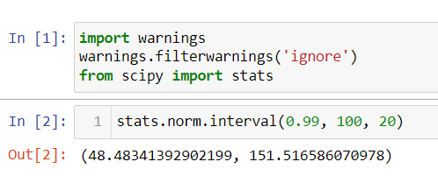

Therefore, the values of a and b, symmetric about the mean, such that the probability of the random variable taking a value between them is 0.99 are: **48.4834** and **151.5165**.

**Method 2:**

The probability of getting value between a and b should be 0.99.

So, the area to the left of a and right of b is symmetrical and it is 1-0.99 = 0.01.

The probability towards left of a = -0.005 (0.01/2)

The probability towards right of b= +0.005 (0.01/2)

We know that, **Z=(X- μ) / σ**

For probability 0.005 the Z-value is -2.57 (from Z table)

**(Z * σ) + μ = X**

Z (-0.005)*20 + 100 = -(-2.57)*20 + 100 = **151.4**

Z (0.005)*20 +100 = (-2.57)*20 + 100 = **48.6**

**The values of a and b are: 48.6, 151.4**

1. Consider a company that has two different divisions. The annual profits from the two divisions are independent and have distributions Profit1 ~ N(5, 32) and Profit2 ~ N(7, 42) respectively. Both the profits are in $ Million. Answer the following questions about the total profit of the company in Rupees. Assume that $1 = Rs. 45
2. Specify a Rupee range (centered on the mean) such that it contains 95% probability for the annual profit of the company.

**Answer:**

Profit1 : Mean = 5, Variance= $3^{2}$, Standard Deviation= 3.

Profit2 : Mean = 7, Variance = $4^{2}$, Standard Deviation= 4.

Mean Profit from 2 different divisions of company:

Mean for Profit1 + Mean for Profit2 = 5 + 7 = 12

Mean Profit in Rupees = 12*45 = **μ =** Rs. 540 million.

Total Standard Deviation:

SD for Profit1 + SD for Profit2 = + = 5

SD in Rupees= 5*45 = **σ =** Rs. 225 Million.

Probability for annual profit = 95%

We have to find the Z at (1-0.95)/2 = Z at (0.05/2) = Z at 0.025

Z at 0.025 = -1.96

Z at -0.025 = -(-1.96)

**(Z * σ) + μ = X**

**Range:**

**Upper Limit** = -(-1.96)*225 + 540 = **981**

**Lower** **Limit** = (-1.96)*225 + 540 = **99**

The required **range** is **(Rs. 99, Rs. 981)**

**Python Code:**

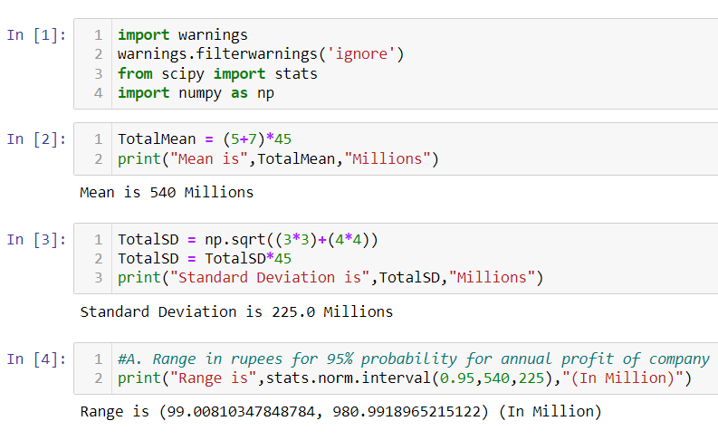

1. Specify the 5th percentile of profit (in Rupees) for the company

**Answer:**

5 percentile = 0.05

Z for probability 0.05 is **-1.64**. (from Z-Table)

X = (Z *σ) + μ

X = (-1.64*225) + 540

**X = Rs. 171**

**5th percentile of profit (in Rupees) = Rs. 171**

**Python Code:**

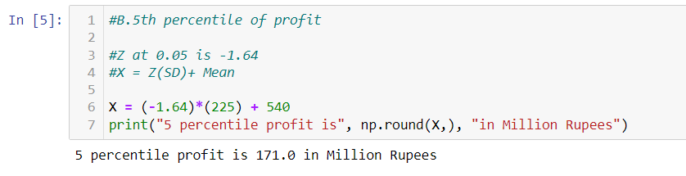

1. Which of the two divisions has a larger probability of making a loss in a given year?

**Answer:**

Probability of Division 1 making loss = P(X<0)

P(X1<0) = P{Z=(0-5)/3}

= P{Z= (-5/3)}

= P(Z = -1.66)

P(X1<0) = 0.04846 = 4.84%

Probability of Division 2 making loss = P(X<0)

P(X2<0) = P{Z=(0-7)/4}

= P{Z= (-7/4)}

= P(Z = -1.75)

P(X2<0) = 0.04006 = 4.006%

We can clearly see that, P(X1<0) > P(X2<0) that is 4.84 > 4.006

Therefore, we conclude that, Division 1 has larger probability of making loss in a given year.

**Python Code:** 